Term 2 2026

Week 3 | TPS Run Club- registrations open for Term 2, please register here  North Harbour Basketball competition- Semester 1 continues for the following teams; Takapuna Alley Oops, Takapuna Wizards, Takapuna Tigers, Takapuna Slam Dunks and Takapuna Stars.  North Harbour Primary School Netball- began this Monday 4th May (Week 3) for Takapuna Sunflowers and Wednesday 6th May for Super Shooters and Takapuna Tulips, enjoy your season.  Rippa Rugby Tournament- TPS has entered four teams; Year 6 boys, Year 5/6 girls, Year 4 boys and Year 3 boys. Practices have begun and each player is keen and excited for the tournament. Tournament 1 - Thursday 21st May  Tournament 2 Thursday 27th August.    Yummy Sticker charts here. Or ask your classroom teacher for a hard copy and please keep collecting as many yummy stickers as you can and raise money for TPS sports gear.  MSport Football Taster- today Chris and Troy hosted football drills and game in the inflatable field. Great to see so many tamariki enjoying themselves.  MSports are offering after school football skills at TPS for five weeks  starting Wednesday 20th May. If you would like to register your child in these sessions register here  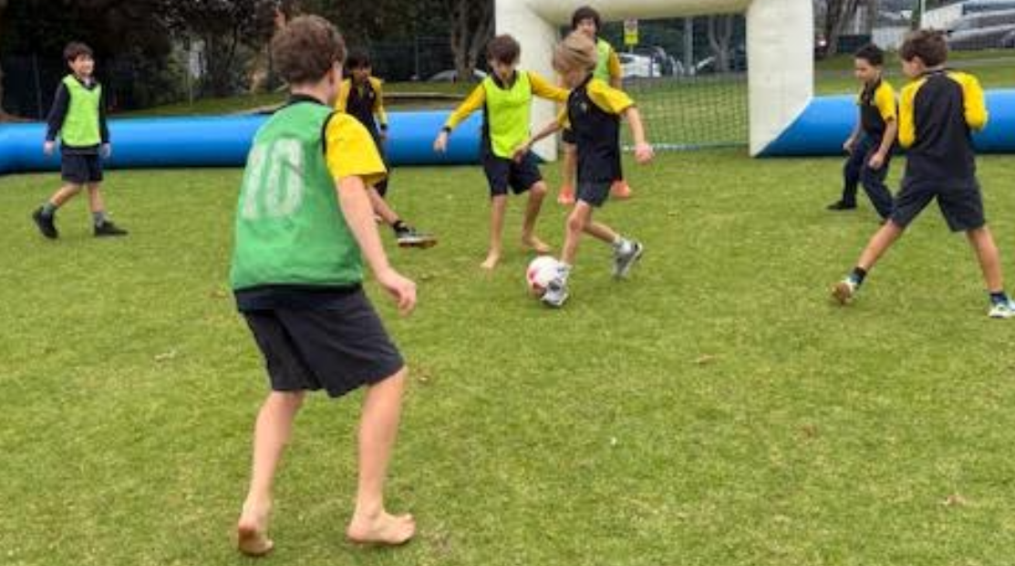  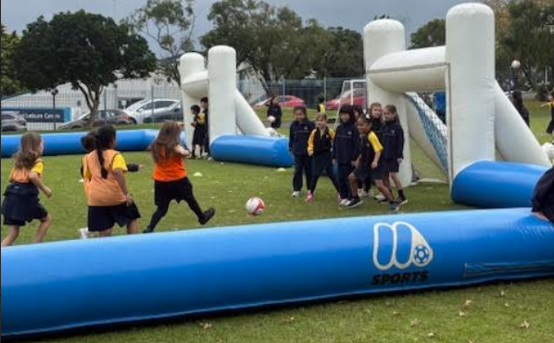  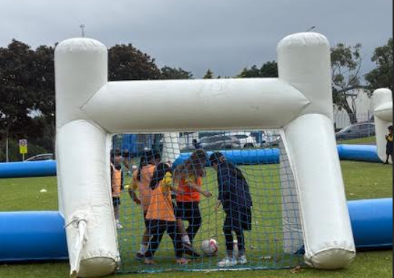  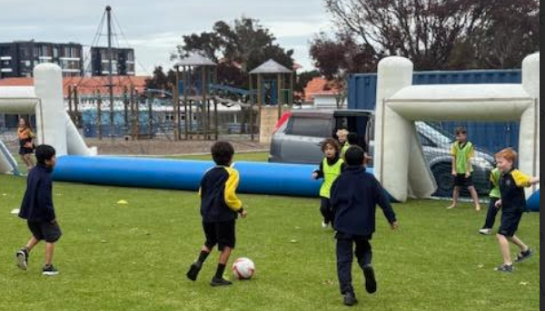  TPS After School Teams Weekly Results  Basketball- Week 2  Takapuna Alley Oops - BYE  Takapuna Wizards - Thank you to our reserves today, close game 23-30 against Birkdale  Takapuna Slam Dunks- Close game and they went down 20-24 against Sunnybrae Cheetahs  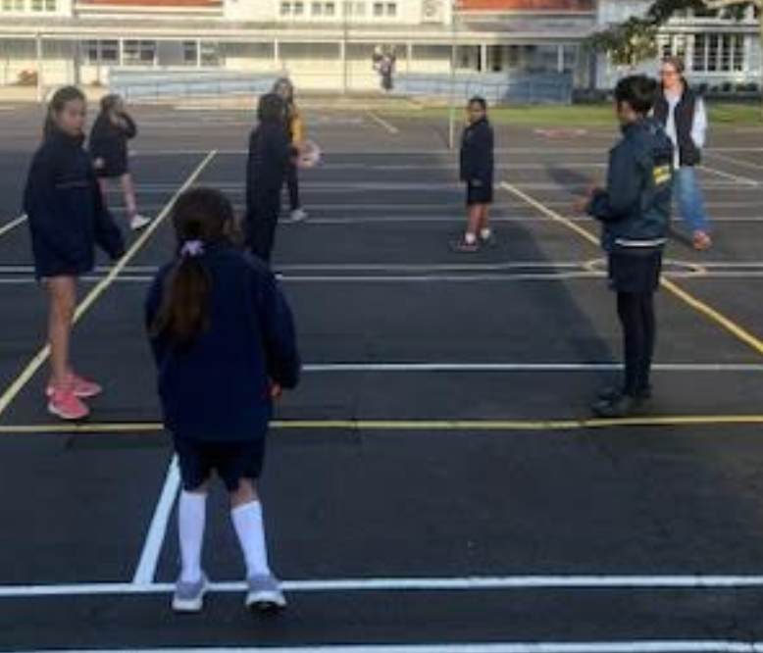  Takapuna Tigers- big win 28 - 18 to HASCA Hawks  Takapuna Stars- 12 v 20 against Willow Park Hawks  Netball- Week 3  Takapuna Super Shooters  Takapuna Tulips  Takapuna Sunflowers-Sunflowers first game against St Mary’s was breathtaking as each team had fantastic passing down the court and both teams scoring goals. At the half time it was a draw. St Mary’s slipped away in the last quarter.  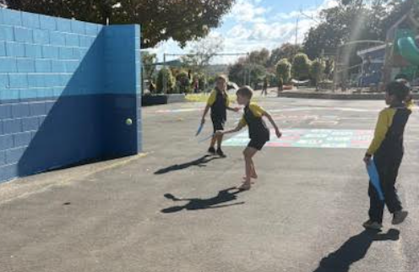  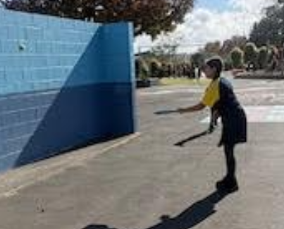  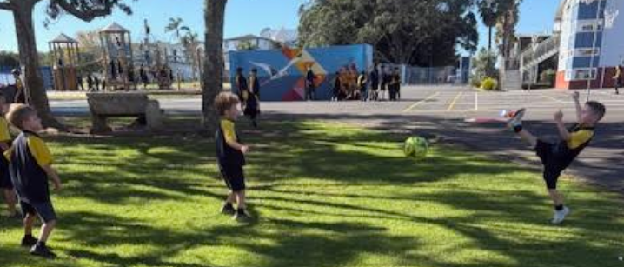  Photo gallery  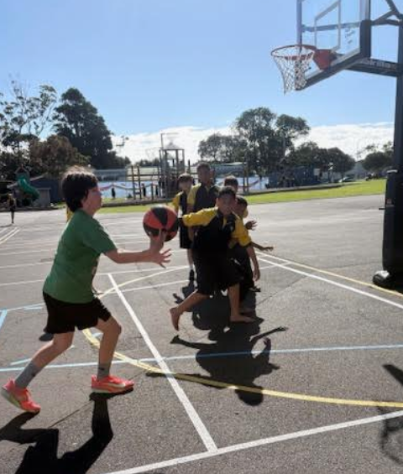  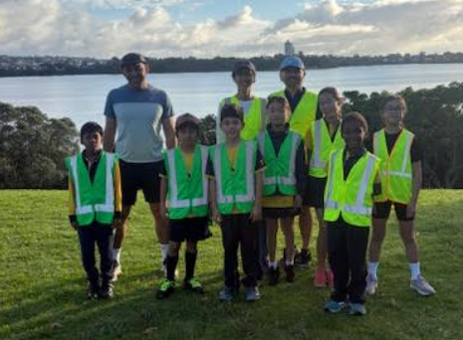  Run Club 6th May  